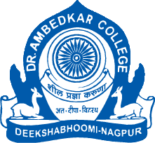
Parampoojya Dr. Babasaheb Smarak Samiti’s
Dr. Ambedkar College, Deekshabhoomi, Nagpur
“Constitution of the Research wing of the Centre for Constitutional Law and Public Policy Debate”
Notice
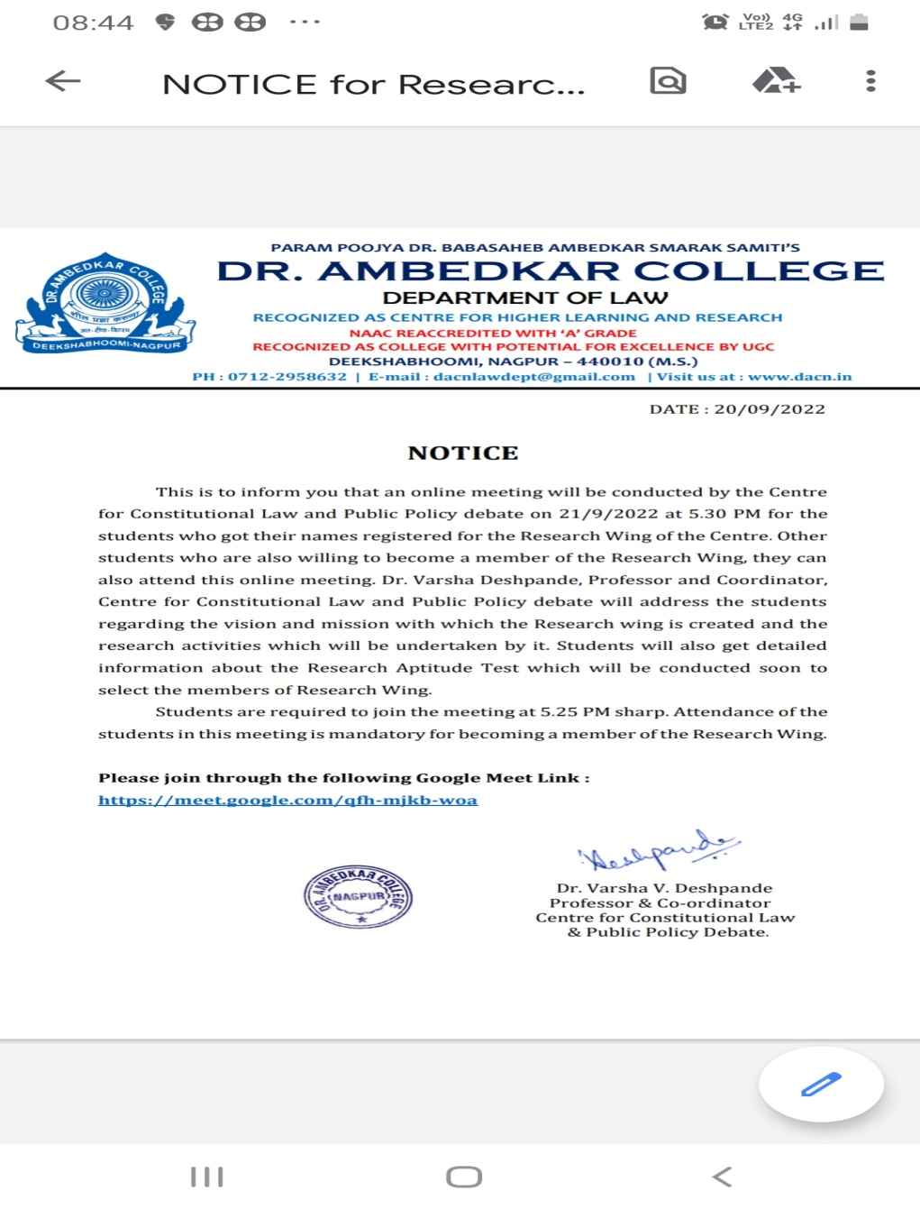

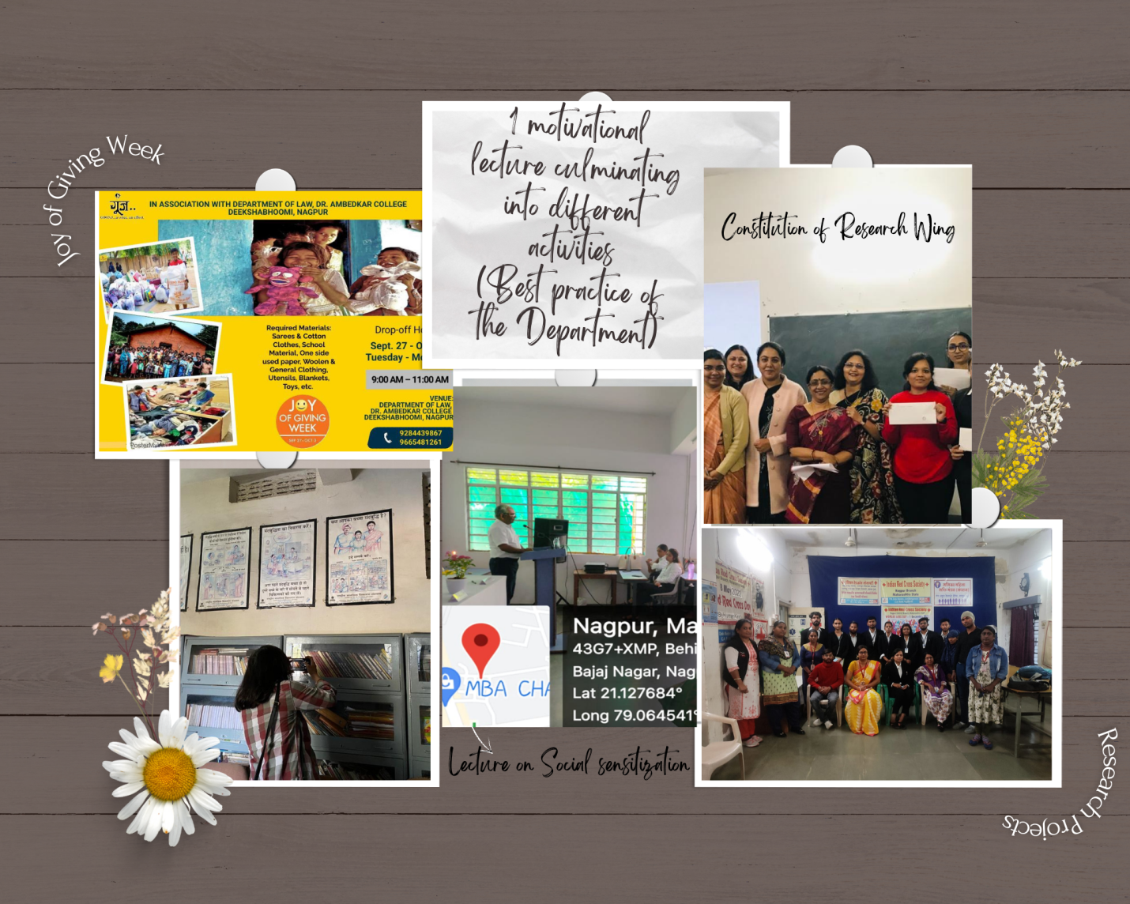
Report:
The Centre for Constitutional Law & Public Policy Debate of the Department of Law, Dr. Ambedkar College, Deekshabhoomi, Nagpur aims at providing a common platform for the exchange of views, deliberation and discussions regarding contemporary issues in the field of Constitutional Law. Its purpose is to bring all the stakeholders including legal luminaries, students, distinguished academicians on one platform to share their knowledge and views regarding issues pertaining to Constitutional Law and Public Policy.
Keeping this vision and mission in mind, the Centre had organised a Guest lecture on the topic “Social Sensitization” on 14th September, 2022. The Speaker of the program was Dr. D.R. Peshwe, Professor, Metallurgical and Materials Engineering and Dean (Faculty Welfare), Visvesvaraya National Institute of Technology (VNIT), Nagpur. The aim of the Guest lecture was to imbibe a basic sense of social responsibility in the students and also to sensitize them about the social causes and issues enabling them to take part in philanthropic activities.
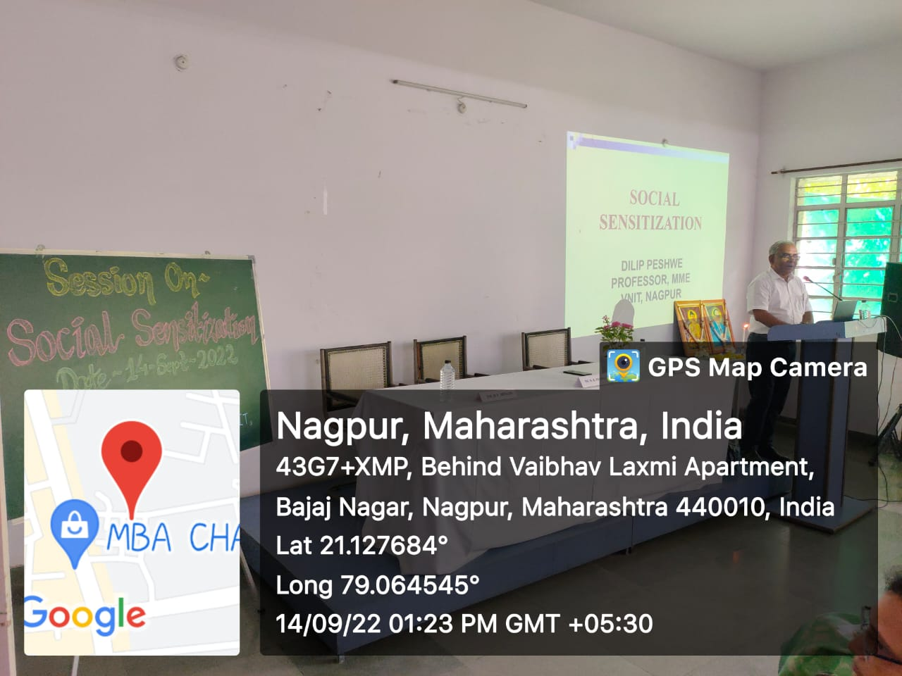
Dr. D.R. Peshwe, Professor, Metallurgical and Materials Engineering and Dean (Faculty Welfare), Visvesvaraya National Institute of Technology (VNIT), Nagpur addressing the students on “ Social Sensitization”
This Guest lecture culminated into various different activities in the Department. Keeping the message delivered through this Guest lecture, the Department then organised the Joy of Giving Week in the College from 27th September to 2nd October, 2022 through the Centre for Constitutional Law and Public Policy Debate in association with Goonj, a Delhi based NGO having its offices all over India. Donations could be given in the form of sarees, school materials, unused papers, woollen clothing, utensils, blankets etc. in the Collection centre.
Constitution of Research Wing:
The Centre then took an initiative to start a Research Wing. The Research Wing has been started to conduct quality research in different areas where critical research gaps have been identified. An online meeting was conducted by the Centre for Constitutional Law and Public Policy debate for the students who got their names registered for the Research Wing of the Centre. Dr. Varsha Deshpande, Professor and Coordinator, Centre for Constitutional Law and Public Policy debate addressed the students regarding the vision and mission with which the Research wing is created and the research activities which will be undertaken by it. Students were given detailed information about the Research Aptitude Test for selecting the members of Research Wing. After this, the Research aptitude test was also conducted through online mode to select the members of the Wing.
Two groups Research Wing Group A and Research Wing Group B were formed each comprising of 5 members.

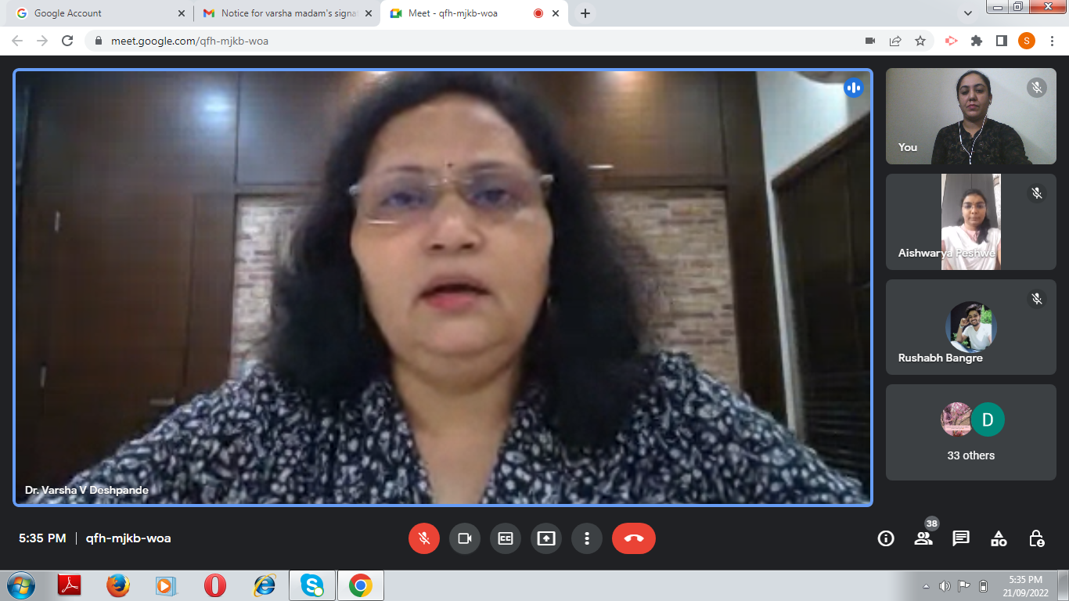
Dr. Varsha Deshpande, Co-ordinator of the Centre addressing the students in an online meeting

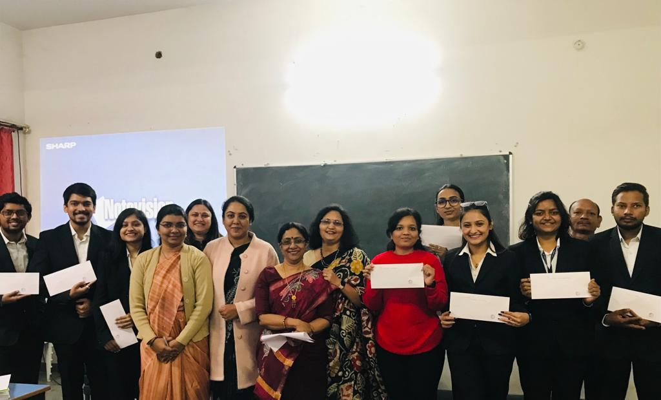
Members of Research wing were officially inducted in the presence of Prof. Dr. H.V. Menon, Head of the Department(Law)
Meetings conducted:
The meetings of Research wing are regularly conducted through online mode and even in the Department for discussing the progress of the members regarding their research project and for giving them any other instructions.
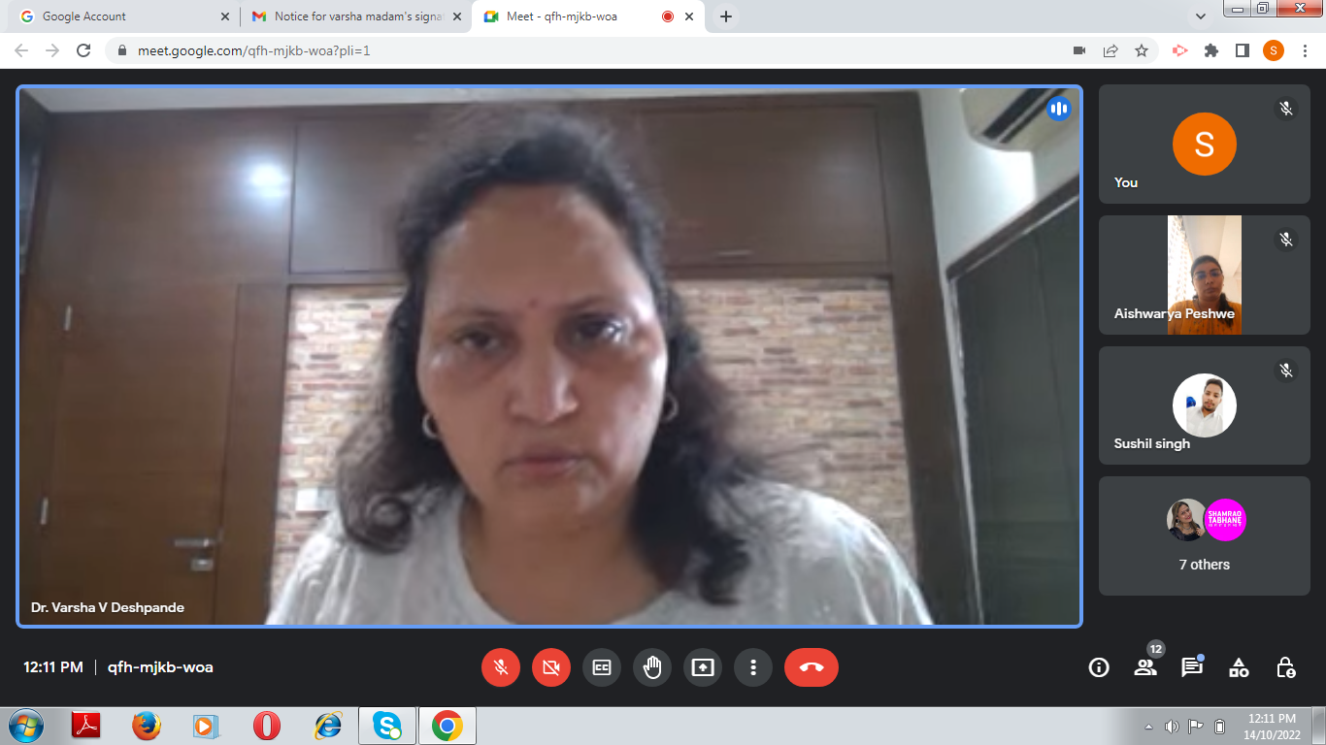
Dr. Varsha Deshpande, Co-ordinator of the Centre in an online meeting of the Research Wing
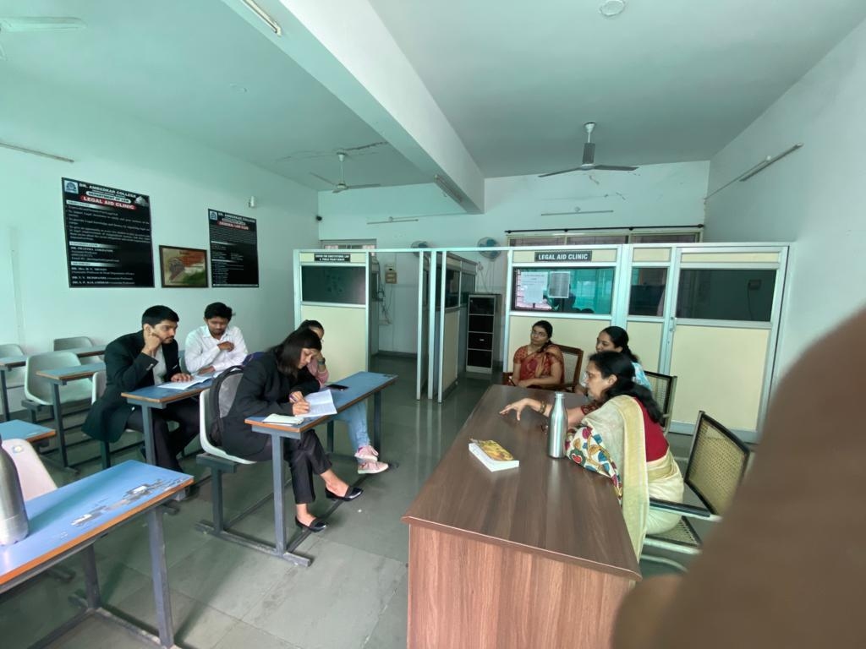
Meeting of the Research Wing conducted in the Department

Research projects taken up by the Research Wing:
The Research Wing decided to take up 2 Research projects on the sensitive issues like the rights and condition of transgenders and Intellectually disabled persons.

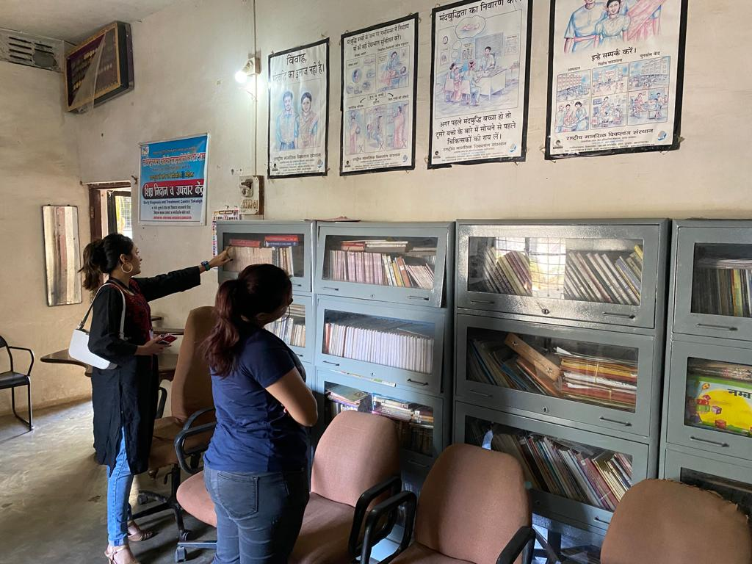
Research Group A engaged in field work
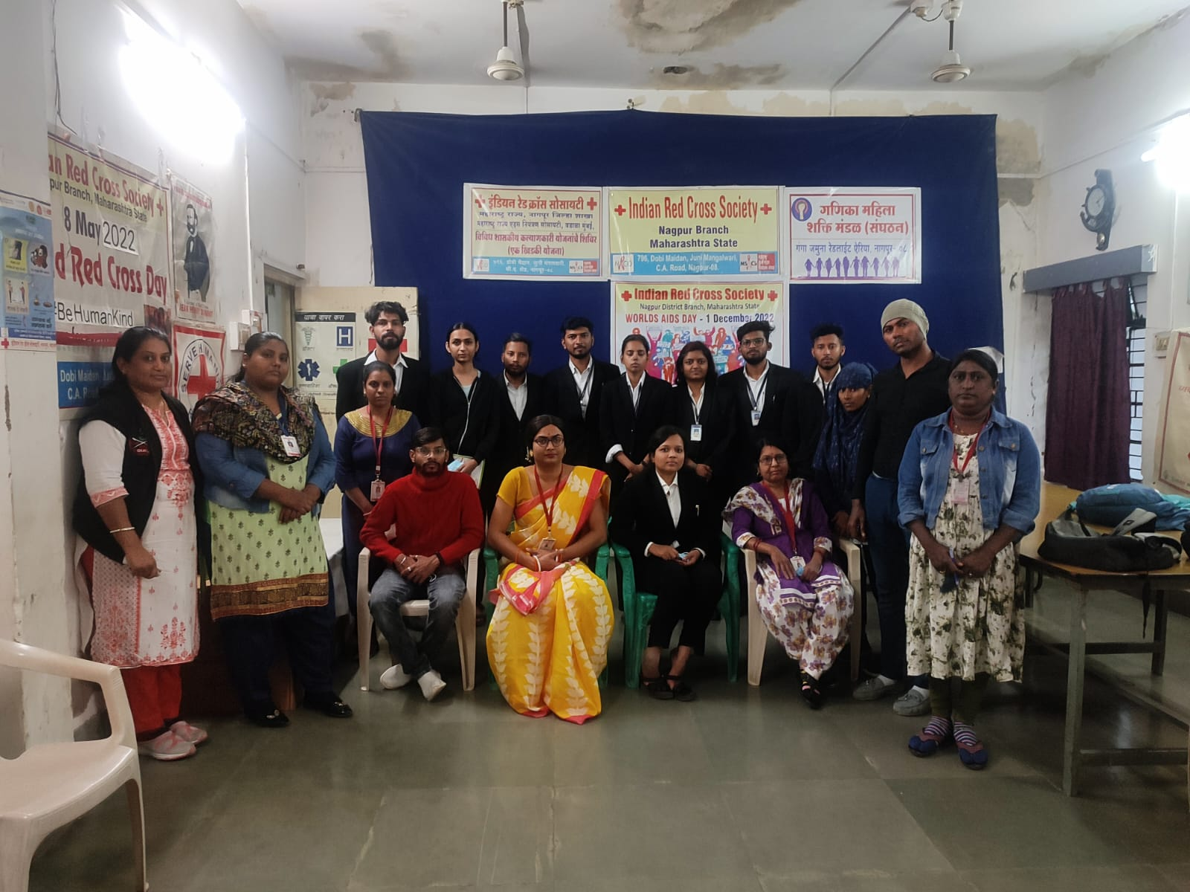
Research Group B engaged in field work

The Research Wing is constituted with an aim to come up with a policy document through which some recommendations can be given so as to improve the existing legislative framework and policies regarding the Transgenders as well as the Intellectually disabled persons. This Research Wing is just a small step and endeavour to fulfil the social responsibility cast on us as a part of this society.

